AEROS Build hardware description
The hardware is split into four domains:
- Brain – Consists of the flight controller, motor and servo drivers and the radio link
- Movement – Consists of the Flight motors, Tilt servos, drive motors and the bearings
- Power- The batteries, buck converters, BEC(battery eliminator circuits) and voltage regulation
- Autonomy and sensors: Nvidia Jetson computers, HD cameras, thermal cameras and Video transmission

The first build will be made keeping in mind the following goals:
A prototype Hybrid UAV capable of Vertical Take off and Landing (VTOL) which can land, rotate its arm pods 90 degrees and the propellor guards acts as wheels which ultimately makes the vehicle act as a rover. Inspired from morphobot m4
Plans of adding sensors and autonomy will be executed in the second stage after the functioning of the vehicle and the flight dynamics are done

1. Brain
Fight controller: This acts as the main computational unit for any UAV which includes IMU (inertial measurement unit) and barometric sensors which enable the drone to be controlled. This is often paired with ESC (electronic speed controllers) which are connected to the battery and the motors and receives signals from the flight controllers and sends the voltage to the motors.
A suitable example of a high class Fc is CUAV V6X: An STM32 H7 based processor with dual redundant IMU and barometers and 16 output peripherals
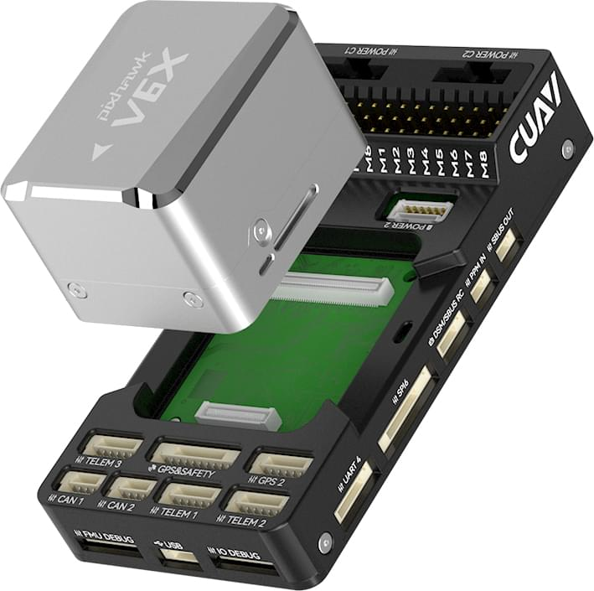
Servo drivers: These take PWM inputs from the flight controller and specifically work with high voltages (6-12V) to power up and control the Servo motors
(The flight controller also has the capabilities of acting as a servo driver if we power the servos separately than the FC)
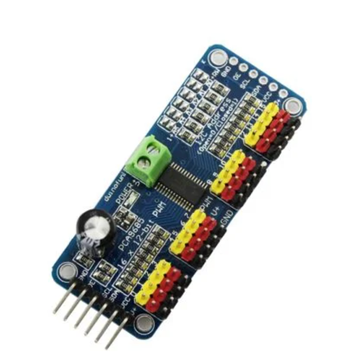

DC Motor drivers: These take PWM inputs from the flight controller and control the DC Motors:
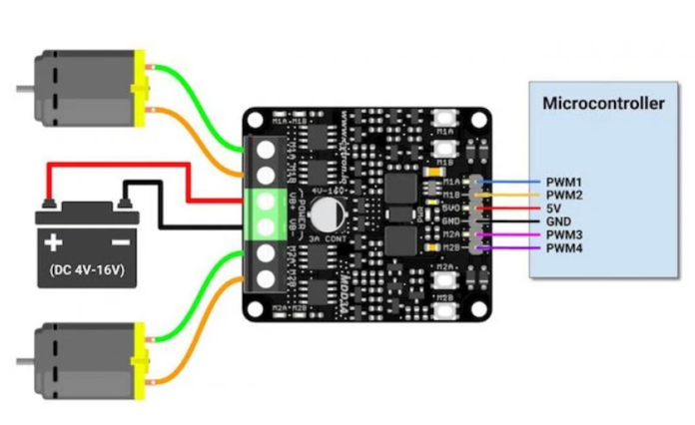
Radio Link: This is the Radio communication required to transmit signals from the operator to the drone. ELRS is an open source technology which works at 2.4 Ghz and gives range upto 10kms
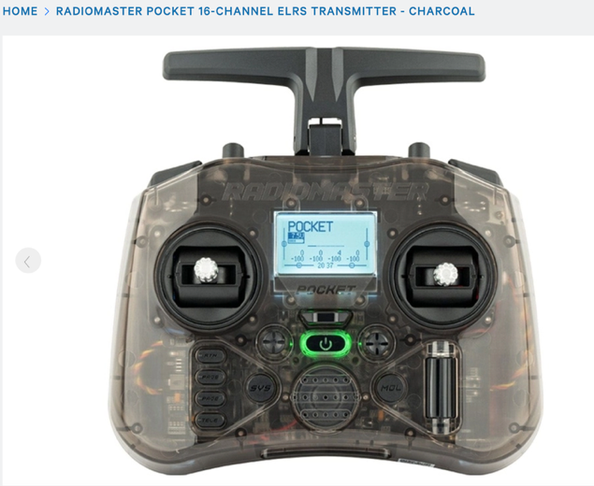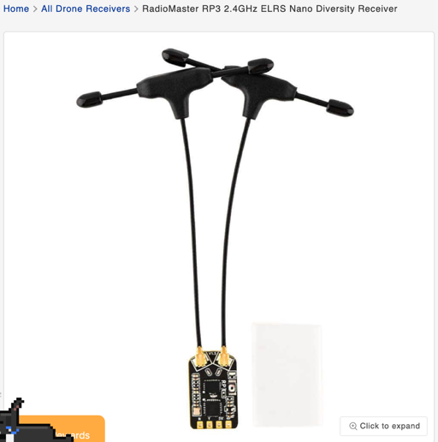
2. Movement
Flight Motors: These are the BL DC motors which will be used in the Drrone to make it fly. We have chosen 1300 KV motors with 7 inch propellors and 6S batteries to give us an individual lift of around 1.1 KG

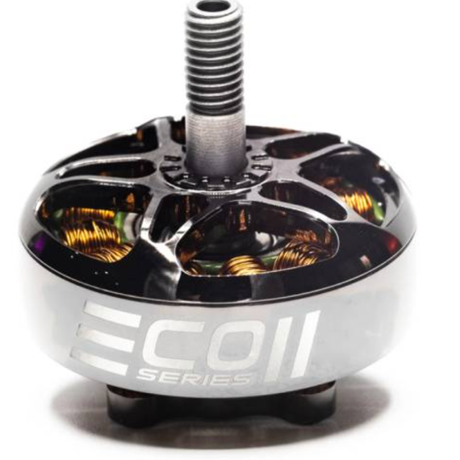
Servo Motors: these will help in transformation of the vehicle and should be high torque to ensure the uav lifts up when in load to fly. A suitable example is DS3230 Servo (30kg) which provides 30Kg.cm torque at 6V with full metal gears.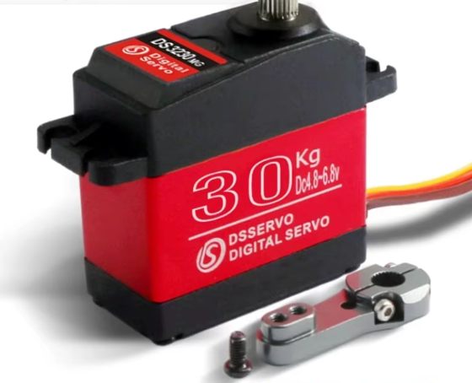
DC Motors: The motors used for driving the vehicle when in rover mode. In the first iteraton, we will be using only 2 as the rear wheels drive to reduce complexity
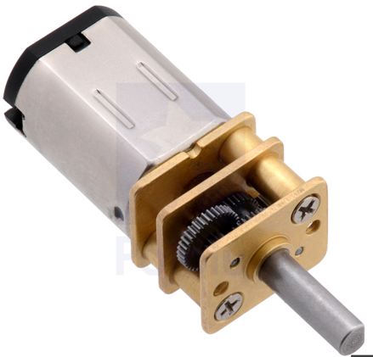
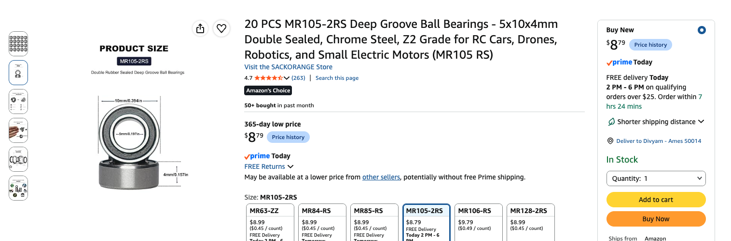

3. Power System
Batteries: This will be used to power the complete structure including the FC, all the 3 sets of motors and the data telemetry.
S,,C and MaH rating:
S rating means the number of cells in series. A single Lipo/LiOn cell ives 3.7 V on average so the total voltage is calculated by 3.7 x S rating
We will be using 6S battery which provides 23V on average

C rating means the current discharge rating, the higher C rating, more current it can allow to push through itself. For this build , a 150C pack suits the best

